

Faculty of Engineering

Computer and Systems Engineering Department

**CSE 371: Control Systems (1)**

Instructor: Prof. Wahied Gharieb Ali

Micro-Project

**PID Controller**

**Submitted by**

Eslam Samir Ali Abu El-Ala [ID: 1200259]

Mohamed Ahmed Anwer Abdelhalim [ID: 1101803]

Nourhan Essam Ahmed Shiba El-Hamd [ID: 1201605]

Shaza Ismail Kaoud [ID: 1200717]

Fall (2015-2016)

Table of Contents

List of Figures 3

1. PROBLEM FORMULATION 4

2. Background 4

3. Analysis 5

4. Simulation 5

4.1. Closed Loop System Simulation 5

4.2. Disturbance Effect on The System 6

4.3. Phase and Gain Margin for Open Loop System 6

4.4. Phase and Gain Margin for Closed Loop System 8

5. Conclusion 10

6. REferences 10

# List of Figures

Figure 1 Closed loop system response 5

Figure 2 Closed loop system response with disturbance 6

Figure 3 Using Matlab to calculate Pm and Gm of the open loop system 6

Figure 4 Matlab results of the open loop system 7

Figure 5 Bode plot of the open loop system 8

Figure 6 Using Matlab to calculate Pm and Gm of the closed loop system 8

Figure 7 Matlab results of the closed loop system 9

Figure 8 Bode plot of the closed loop system 10

# PROBLEM FORMULATION

For the given system,

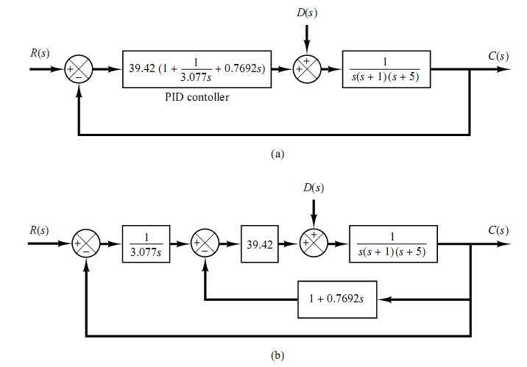

1. Simulate the closed loop system using the MATLAB/SIMULINK for a unit step input u(t)
2. Explain, which parameter in the PID block has to be modified to decrease the settling time.
3. Study the effect of a constant disturbance input = ±0.1u(t) on the system response.
4. Compute the gain margin and phase margin for the open loop without PID controller and closed loop system with PID controller.

# Background

The PID is the most popular feedback controller algorithm used. It is a robust easily understood algorithm that can provide excellent control performance despite the varied dynamic characteristics of processes.

The PID algorithm consists of three basic modes: the Proportional mode, the Integral mode & the Derivative mode.

In the *s*-domain, the PID controller may be represented as:

$$U\left(s\right)=(K_{p}+ \frac{K_{i}}{s}+ K_{d}s)E(s)$$

In the time domain:

$$u\left(t\right)= K_{p}e(t)+K_{i}\int_{0}^{t}{e(t)dt} + K_{d}\frac{de(t)}{dt})$$

u(t): The PID output

e(t): The Error between the output and the set point.

Kp: Proportional Gain

Ki: Integral Gain

Kd: Derivative Gain

While varying each element of the PID controller, the system responses differently. So, the effect of each of these elements on the system must be analyzed in order to get the desired response of the system using the PID controller.

The proportional controller’s main responsibility is to force the system to go to the desired value fast, hence, decreases the rise time, but overshoot and settling time increases. Also, steady-state error never reach zero.

When adding integral controller’s effect, its main advantage is eliminating the steady-state error. On the other hand, it increases overshoot and settling time also.

When the effect of derivative controller is added, overshoot and settling time decrease while rise time increases.

To sum up, to control the system, P, I, and D values must be chosen with care.

# Analysis

b) To decrease the settling time, derivative controller must be increased. So, 39.42 * (0.7692 s) must be increased.

Explanation: derivative controller gets the derivative of the error, form the derivative law:

(New error – Old error) / ∆t

And as long as the output is approaching the desired value, the new error is decreasing, so the value of the derivative is always negative, since new error is always less than old error.

So derivative is always trying to brace the system. So overshoot decreases, hence, settling time decreases.

# Simulation

## Closed Loop System Simulation

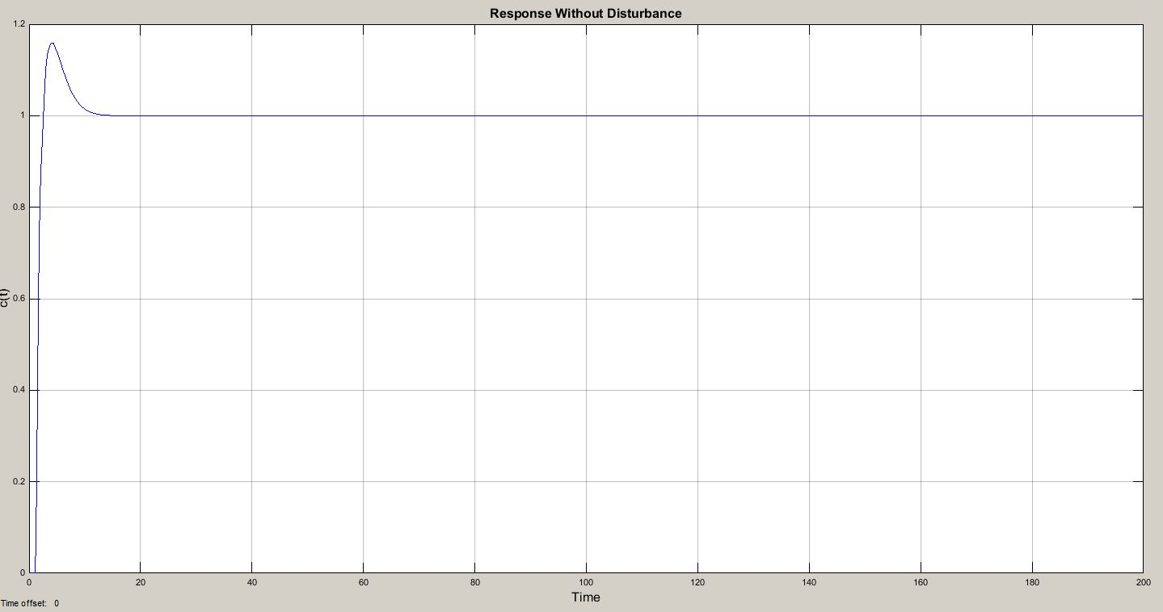

Figure 1 Closed loop system response

## Disturbance Effect on The System

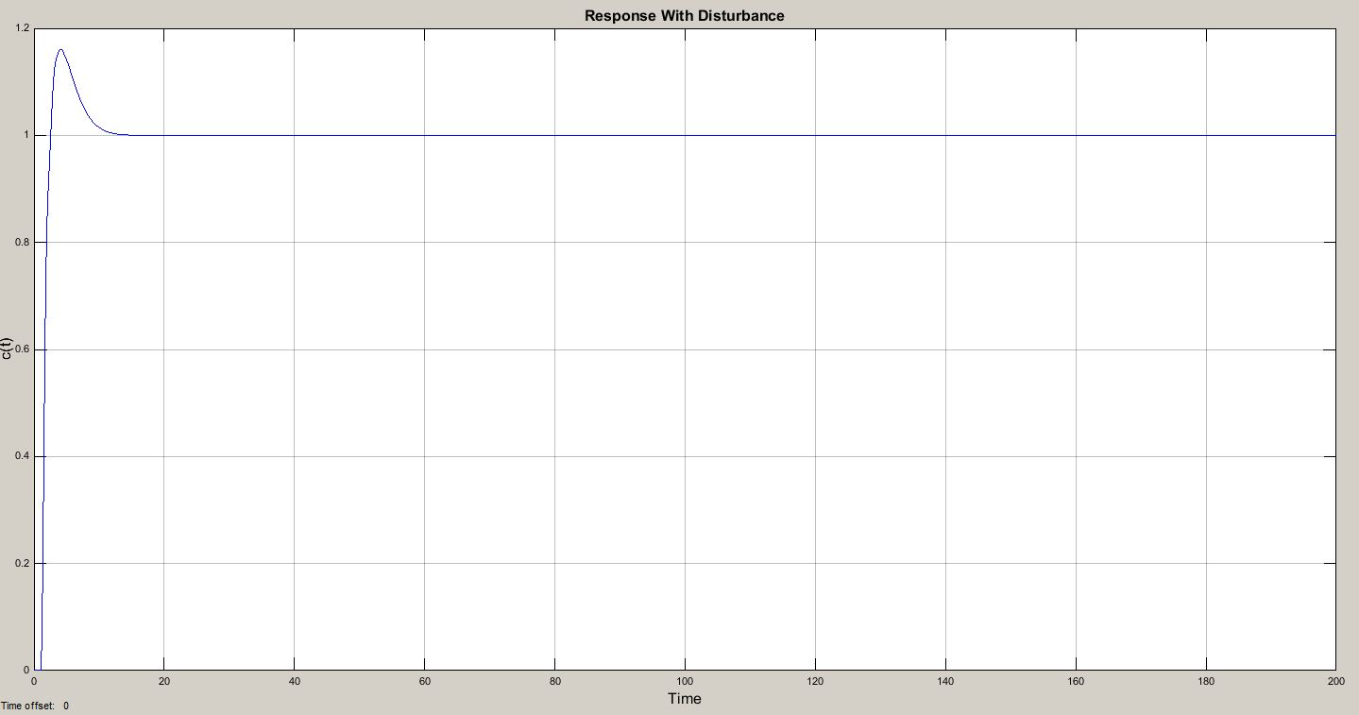

Figure 2 Closed loop system response with disturbance

## Phase and Gain Margin for Open Loop System

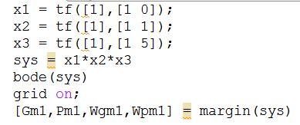

Figure 3 Using Matlab to calculate Pm and Gm of the open loop system

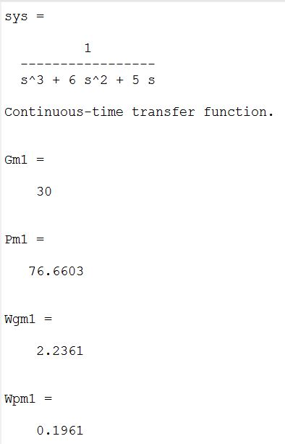

Figure 4 Matlab results of the open loop system

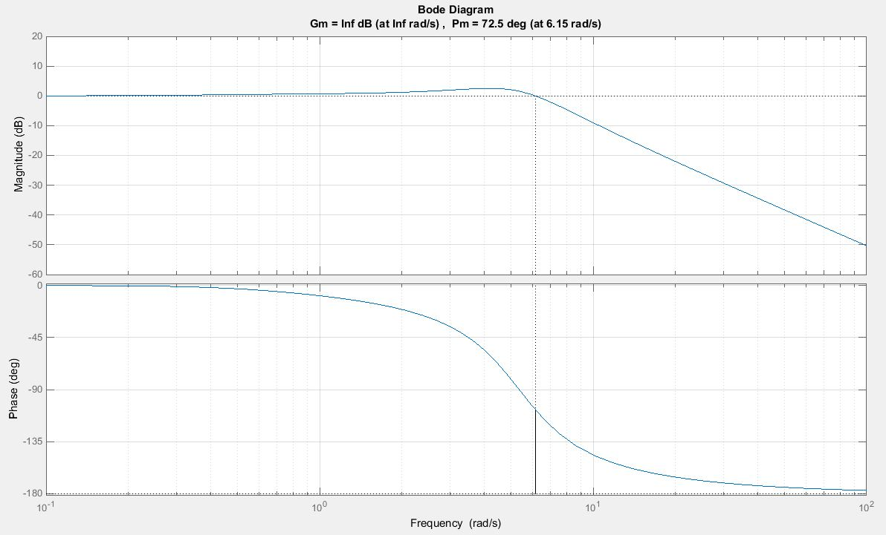

Figure 5 Bode plot of the open loop system

## Phase and Gain Margin for Closed Loop System

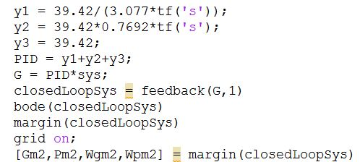

Figure 6 Using Matlab to calculate Pm and Gm of the closed loop system

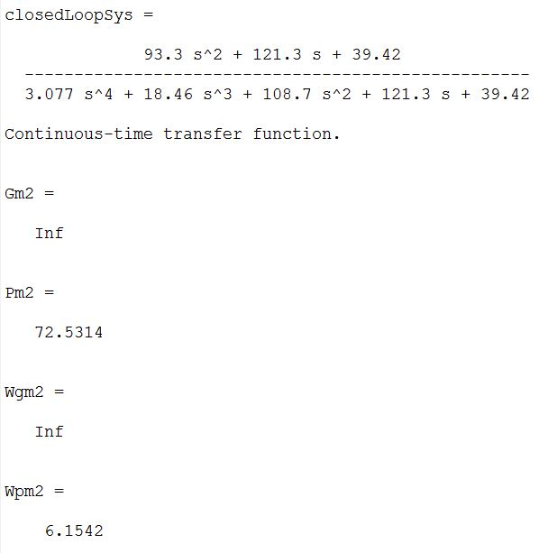

Figure 7 Matlab results of the closed loop system

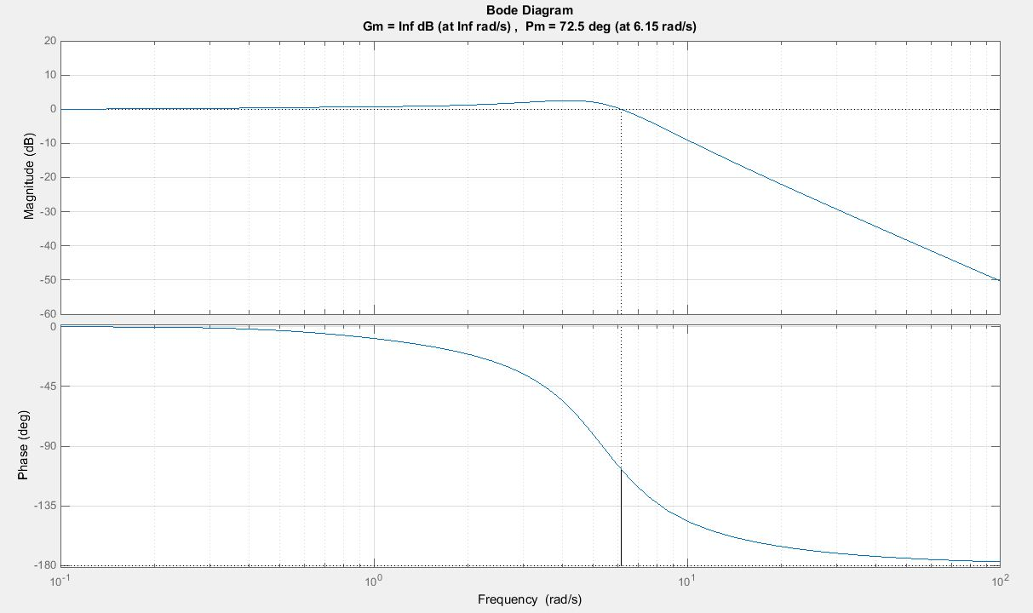

Figure 8 Bode plot of the closed loop system

# Conclusion

PID is a very powerful controller. One must choose the values for proportional, integral, and derivative controllers with care to have the desired performance of the system as each of them has positive and negative impact on the system.

# REferences

[1] “Modern Control Engineering”, 5th edition, Katsuhiko Ogata.

[2] Lecture Slides: “Topic#11 PID Controller Design”, Dr. Wahid Gharib, 2015.

# 7. Appendices

## MATLAB code

x1 = tf([1],[1 0]);

x2 = tf([1],[1 1]);

x3 = tf([1],[1 5]);

sys = x1*x2*x3;

bode(sys);

margin(sys);

grid on;

[Gm1,Pm1,Wgm1,Wpm1] = margin(sys);

y1 = 39.42/(3.077*tf('s'));

y2 = 39.42*0.7692*tf('s');

y3 = 39.42;

PID = y1+y2+y3;

G = PID*sys;

closedLoopSys = feedback(G,1)

bode(closedLoopSys)

margin(closedLoopSys)

grid on;

[Gm2,Pm2,Wgm2,Wpm2] = margin(closedLoopSys)